**Lab Program: 10**

1. **For a given set of relation tables perform the following: Creating views (with and without check option), Dropping views, selecting from view.**

**View: - View is the virtual table that does not physically exist.**

**A view is created by a query joining one or more tables.**

**Views display only selected data.**

**Views are used for security purpose because they provide encapsulation of the name of the table.**

**Let us consider the table of Emp and Dept created and we will create the view on both emp and dept table.**

**Step 1:-**

**DEPT (DNO: integer; DNAME: varchar; DLOCATION: varchar)**

**SQL> Create table DEPT**

**(DNO int (4) primary key,**

**DNAME varchar (20) Not Null,**

**DLOCATION varhcar (20));**

**Table created**

**Execution:-**

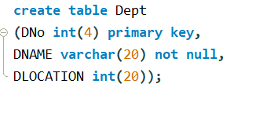

**SQL> Desc DEPT;**

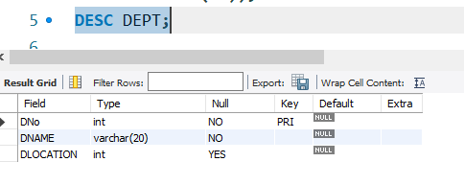

**Step 2:-**

**EMP (ENO: integer; ENAME: string; EBDATE: Date; ADDRESS: Text; GENDER: text; SALARY: int; DEPTNO: int)**

**SQL> Create table EMP**

**(ENO int (6) primary key,**

**ENAME varchar (20) Not Null,**

**EBDATE date,**

**ADRESS varchar (20),**

**GENDER char (3),**

**SALARY int (10) not null,**

**DNO int (4) references dept);**

**Table created**

**Execution:-**

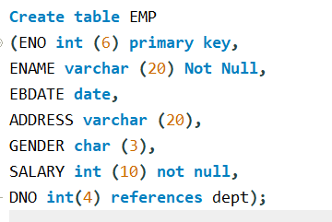

**SQL> Desc EMP;**

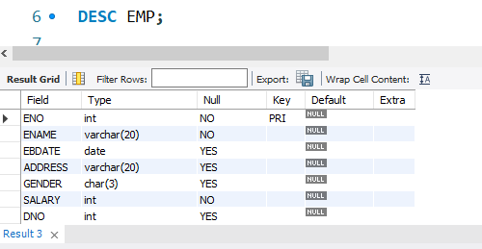

**Step 5:-**

**Insert into dept (DNO, DNAME, DLOCATION) values (2,’ACCOUNTS’, JAYANAGAR’);**

**1 rows created.**

**Insert into dept (DNO, DNAME, DLOCATION) values (4,’RESEARCH’, KENGERI’);**

**1 rows created.**

**INSERT INTO DEPT (DNO, DNAME, DLOCATION) values (5,'ADMIN','SOUTHEND');**

**1 rows created.**

**Execution:-**

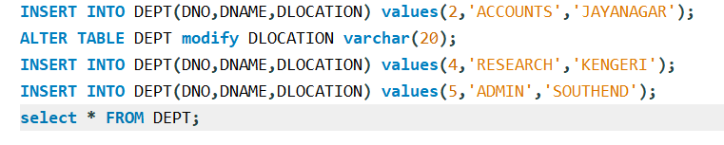

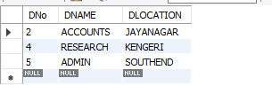

**Step 6:-**

**INSERT INTO EMP (ENO, ENAME, EBDATE,ADDRESS,GENDER,SALARY,DNO)**

**Values (1001,'ANIRUDH','1990-01-14','BANGALORE','M', 45000, 4);**

**Execution:-**

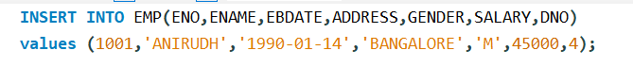

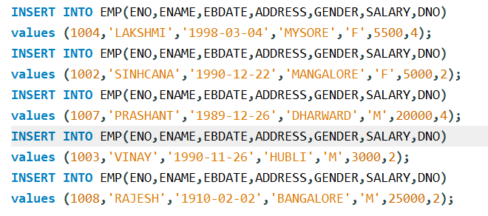

**Note: - Enter this values into the table EMP as shown below**

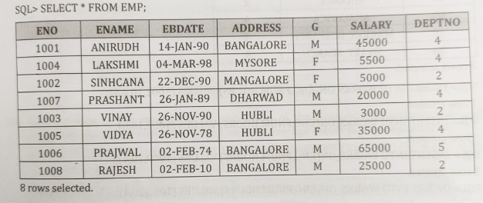

**Note: - Enter this values into the table EMP as shown below**

**Execute the Following Queries:**

1. **For a given set of relation tables perform the following : Creating views(with and without check option), Dropping views, selecting from view.**
2. **Without Check Option :-**

**Step 1: -**

**SQL> create view emp_dept as**

**(select E.ENO,E.ENAME,E.SALARY,E.DNo,D.DNAME**

**FROM emp E,dept D WHERE E.DNO=D.dNo);**

**View created.**

**Step 2 : -**

**SQL> select * from emp_dept;**

**Execution:-**

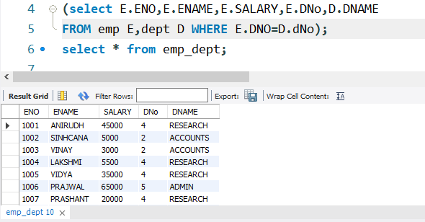

**8 rows selected.**

**Step 3: - Insert record into the view:**

**SQL>** **insert into emp_dept (ENO, ENAME, SALARY, DNO)**

**Values (1009,'SRIKANTH', 9000, 5);**

**Step 4:- Select * from emp_dept;**

**Execution:-**

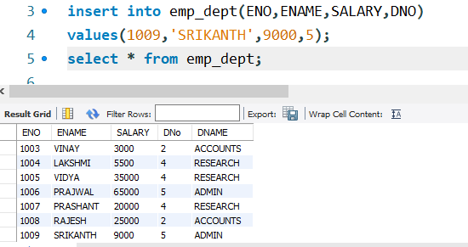

**Step 5:- Drop view**

**SQL> DROP VIEW emp_dept;**

**View dropped.**

1. **With Check Option: - The with CHECK OPTION clause is used to prevent the insertion of rows in the view where the condition in the WHERE clause in CREATE VIEW statement is not satisfied.**

**Step 1: -**

**SQL> create view emp_view as**

**(select ENO,ENAME,SALARY**

**FROM emp where salary<=50000) with check option;**

**select * from emp_view;**

**View emp_view created.**

**Step 2 : -**

**SQL> select * from emp_view;**

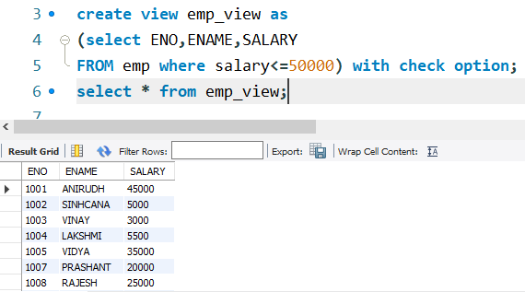

**6 rows selected.**

**Step 3 : - Insert a row where employee salary is less than 50000.**

**SQL>insert into emp_view (ENO,ENAME,SALARY)**

**values(1011,'SNIGDHA',39000);**

**Step 4 : -**

**select * from emp_view;**

**Execution:-**

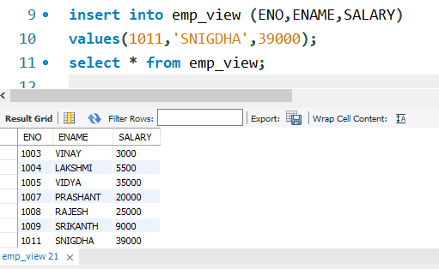

**7 rows selected.**

**Step 5 :- insert a row where employee salary is greater than 50000.This will give an error.**

**SQL>insert into emp_view (ENO,ENAME,SALARY)**

**values(1011,'SNIGDHA',99999);**

**with check option where-clause violation.**

**Step 6:- Drop view**

**SQL>Drop view emp_view;**